FOOD, FOR EATING

And a guide on how to make it
With much love, by yours truly

Charlie
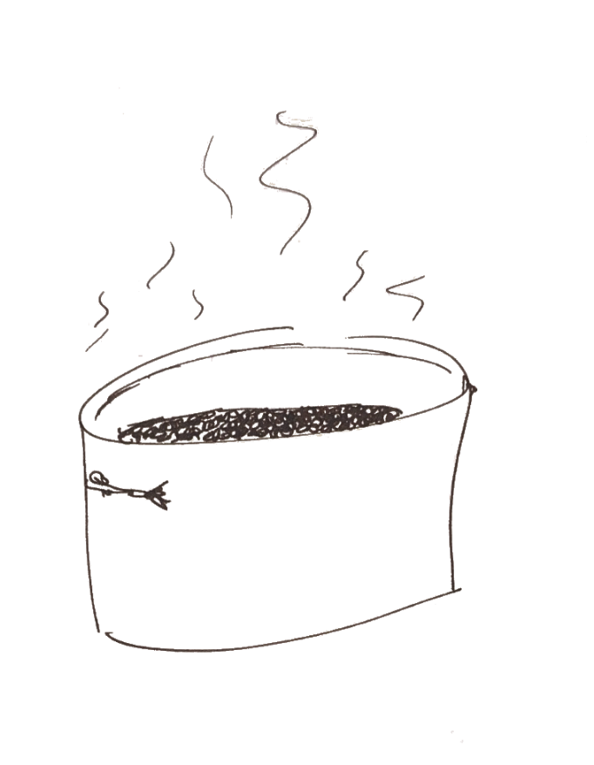
Right, so I like to talk to people. It’s a human thing; we crave companionship. Anyways, I’ve started to notice a trend. Consistently, the very same people who ask “Charlie how tf do you have so much energy all the time” often later say something like “I don’t eat vegetables,” or “Instant noodles are a full meal, especially if you put an egg in it.”
I’ll be real with you, when I eat instant noodles, I feel more depressed than sated.
This has led me to conclude that most of y’all are malnourished, and my friends, you deserve better than to be gouged by the claws of something so preventable.
So hey!
Eat!

Since it’s deeply impractical for me to cook for everyone all the time (restaurant finances are super tight at the best of times, and I really do enjoy having a life outside of work), let me teach you how to fish, so to speak.

About food…
You gotta hit your food groups.
Get those macros, champ.
Acquire the nutrients, and put them in your belly. It is where they belong.
Broadly, you get your proteins (and those associated sweet gains, yo) from stuff like meat, tofu, lentils, beans, and protein powder. I think we can also synthesize some protein from vegetables, but don’t quote me on it.
You get vitamins and minerals and stuff from vegetables. To my knowledge you cannot eat too many vegetables, so if you’re cooking just put more veggies than you think you need. There’s really no worst-case scenario here. More vegetables = better.
Carbs (rice, bread, barley, noodles; all the classics) are great to pair with other foods, since they’ll crossfade your blood sugar and mix you up a good time. Most cuisines around the world already do this. Think curries over rice, noodles in soup, and breads making a sandwich. You get what I mean.
You should be aiming to munch on at little of each of these with every meal. Generally speaking, any meal that ties together the three above categories, will be pretty good. And you’ll feel good. Success.
In the recipes that (will) follow, take a peep and see if you can trace down the food groups mentioned: protein, carbs, vegetables.
Before we start cooking, let’s take a quick tour of the kitchen, and the tools of the trade:


First up is the knife, and it’ll be central to most meals you make.
Note how to hold it:
Your index finger pinches the blade against your thumb (Fig. 1).
Don’t put your finger along the spine of the knife. I’ve seen y’all do it. It doesn’t work well, and it looks silly. Remember this next time you hold a knife. Look cool. Be cool. Hold it the proper way.
Fig. 1
We hold the knife like so because it shifts the cutting action from our fingers to our wrist, which is much stronger. More muscles on the knife means more control, and more control means better food and less injuries.
On the topic of knives, it bears mentioning that the best knife is a sharp knife. You shouldn’t have to be fighting with your tools in any endeavour, especially one so important as eating.
If your knife sucks, go buy a new one.

It’s important that you look after your knife. A good chopper/slicer will last you for a long time, provided you take decent care of it.
Mainly, keep it clean and don’t bang it around unnecessarily.
I once saw one of my buddies use their knife as a can opener and I almost cried. Be gentle to my tender heart; use tools for only what they were designed to do.
Anyways, here’s a secret tip on keeping your knife sharp:
When you’re scraping all your freshly-chopped goods off the cutting board, scrape using the back of the knife.
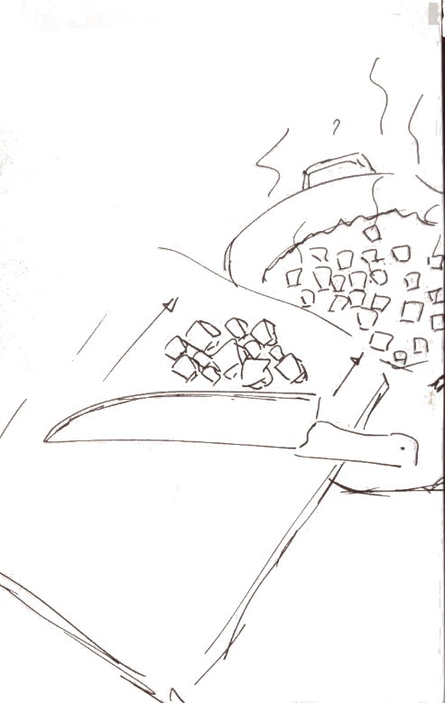
It really goes a long way to saving the blade.

Some other utensils that I would recommend are:
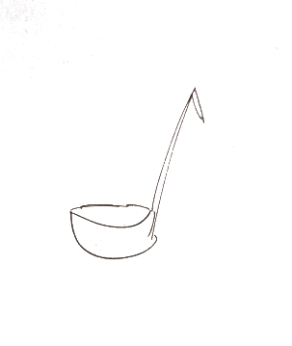
A big ladle. When you’re done cooking & it’s come time to serve, it’s much easier to scoop out one or two dips than to try filling a bowl with a soup spoon (or risk the mess or pouring).
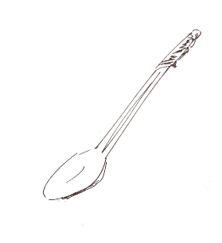
A long cooking spoon is good for stirring things in general. You can use a wooden spoon for this if you’d like; it’s all up to your own aesthetic preference.
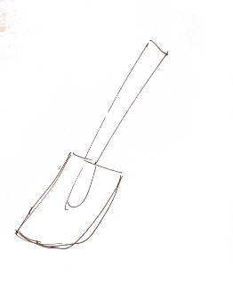
A spatula — Honestly in a pinch you could probably make do with either a spatula and no cooking spoon, or a spoon and no spatula. But you know what? We dream our wildest dreams, and so we can conjure a world where we have both.

A big pot. Bigger than you think you need. Too much food is rarely a problem, and if you make too much? Invite a friend over! Invite two friends over! People love meals, and sharing food brings joy to everyone involved. Get a big pot.

HOW TO PREP STUFF
Ok I’ll be real with you, a lot of cooking is mechanical. Like yeah sure you can just throw a bunch of whole ingredients and spices into a pot or a pan and that’s technically fine but it never quite lands the same (it’s a good trick to know if you’re ever feeling mega depressed though). The more you work with your ingredients, the better you understand them, and the better you understand them the better you’ll be able to play with them in your dishes.
I like to think to how it’ll be eaten — I notice this a lot when eating sandwiches. You take a bite and a whole slice of tomato decides to come for the ride. We love tomatoes! It’s a great bite. But then the rest of the sandwich is at a dearth of our favourite fruit.
So take this into account when you’re cutting stuff up. Do you want each bite to highlight a different ingredient? If so, use large cuts. Chop things so that they’re approximately bite-sized (anything larger is just impractical). If you want to emphasize the meal as a whole, and the interplay of ingredients, dice finely.

Chopping ingredients can be a bit awkward at first, but with courage and skill you will eventually prevail.
Here’s a few guidelines on the best ways to prepare some of the most common vegetables.
For the less common ones, you can usually just adapt these techniques. Tomato tomato, amirite?
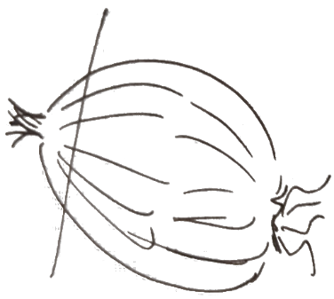
ONION:
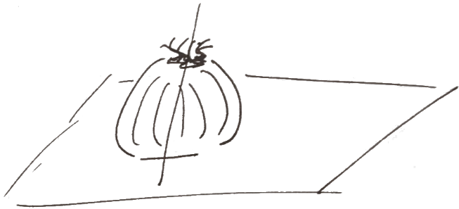
- Right so start by chopping off the top of it. Not the part with the roots. This gives you a flat surface that won’t roll around when you get to step 2.
- Give it the ol’ CHOP right down the middle. Get yourself two halves of an onion.
CHOP.
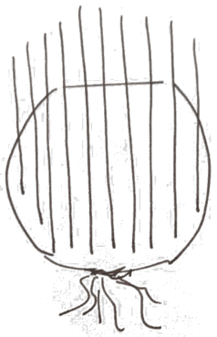
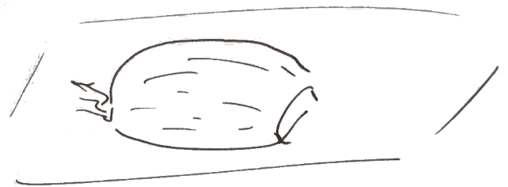
- Peel it real good. Get rid of the tough skin; it does not taste very good at all. Compost this stuff for bonus Cooking Points™.
- Cut a bunch of lines down your freshly-peeled onion like so:
Note that you don’t cut all the way through! This holds all the pieces together, making it much easier to fully dice. You can do the last cuts later.
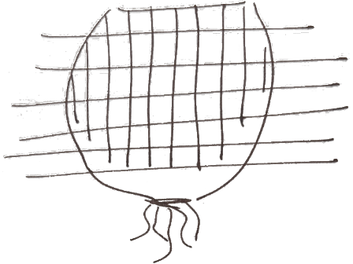
- Ta-dah! Smash out a few slices acrossways, and you’ll see the onion fall apart into perfect little cubey bits. Easy as that.

CARROT:
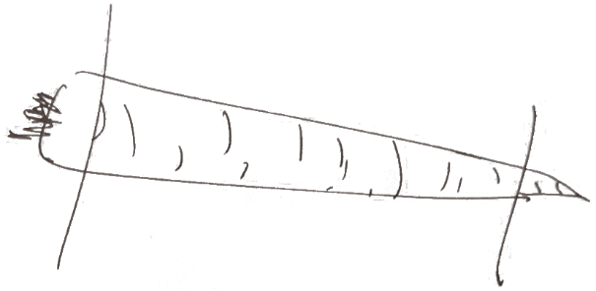
- Chopping carrots is pretty chill, but you’ve gotta put your heart into it. They’re tough little buddies, and so it’s best to use leverage with the knife. Plant the tip, and push down with your arm. Again; push down, don’t go at it like a meat cleaver. You’ll dull your knife and I will cry.
To start, chop off the ends like so:
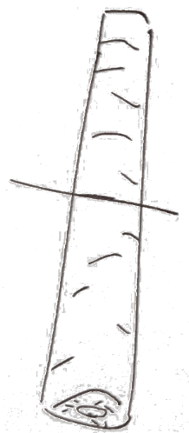
- Chop em again.

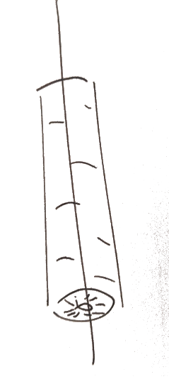
- Chop! Chopchopchop! Another middle but different, this time. Carrots aren’t very technical, so I’ll just load you up with pictures and we’ll call it a few thousand words.



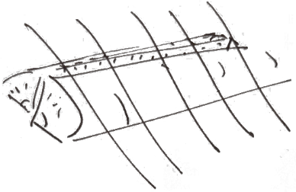

Great success. Well done, team. We did it.
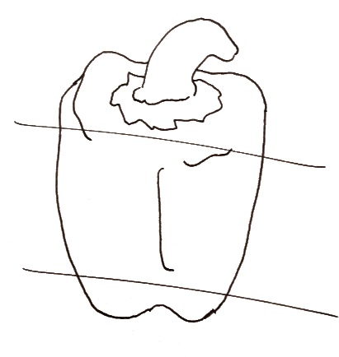
PEPPERS

- Chop the top and the bottom off and cut ’em up as you think is best. I’m only walking us through the body of the pepper here.

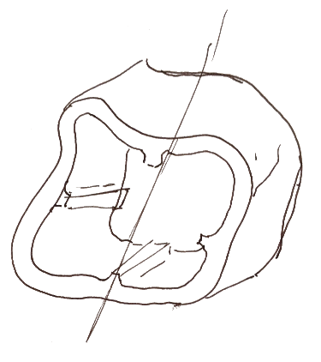
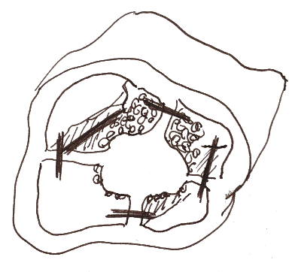
- This part looks a bit messy, and is kind of involved. Slide the knife down the inside of the pepper, and cut through the soft part that joins the seedbody to the tasty shell. This is debatably the wildest thing you should ever have to do with a knife. You can dunk the seeds into the compost, we don’t need them anymore.
- A hollow body of peppery goodness! Half it.
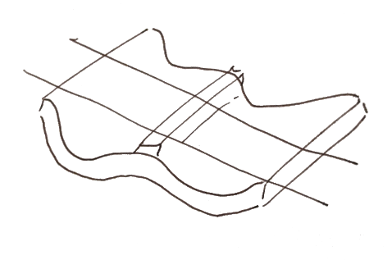
- Zip a bunch of slices down the length of your halves. By now you should know what’s coming.
…
Yeah buddy.
We’re gonna dice it.
You can make some cuts along these slices to make squares, or just leave them as strips and call it a vibe.
RECIPES.
THE GOOD STUFF
Right so many of these recipes look similar, as in they get eaten in a bowl. Rather than draw the same bowl many times, I’ll just give you the one. Use your imagination if you are the visually-inclined type.

I drew a bagel with this, because sometimes I forget to make rice, or don’t feel like using another pot to cook noodles.
You could do this too, if you ever feel like it.

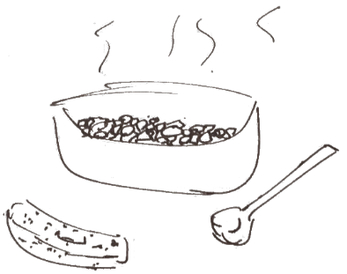
Lentil Curry
Honestly I don't really measure things out when I'm cooking so take the ingredients and just put as much of them as you think would be good. Don't be shy on the spices.
3 onions
1 medium head of garlic (all of it)
A smallish chunk of ginger
4 stalks of celery
2 largish carrots
1 sweet potato
A bunch of green lentils
Some pearl barley (not too much, but you do you. They'll adjust your carbs/protein balance in the meal)
A bunch of frozen spinach (like 5-6 cubes)
Spices:
Salt, pepper to taste
A little bit of cinnamon
A tiny bit of turmeric (if you can taste it, you put in too much)
A moderate amount of curry powder
Like a tablespoon of cayenne powder? You can adjust this for spiciness to taste
I used like 1.5 tablespoons of tarragon because I had some on hand, but you can really just see what you have in your spice drawer and add that.
Some paprika

----------------------
Chop up your vegetables, and cook them – do the onions first so they have time to caramelize while you're chopping. Doing the celery/carrots next is good because the heat softens them, meaning your curry will be done faster.

Once all your vegetables are chopped, top up with water, and add the lentils and the barley.

Add the spices and let it simmer for a while. It's pretty chill.

Beef, Rice, and Cabbage tomato soup
1 large onion, diced. Maybe 2 small ones idk. Onion is a good flavour, you can’t really add too much
a couple celery stalks, chopped up
a couple carrots, chopped up
some ground beef
like 1/3 head of green cabbage? roughly chopped; bite-size pieces
a couple garlic cloves
1 can of diced tomatoes
1/2 cup of uncooked rice
some frozen peas (like 1/2 - 1 cup, maybe?)
some ground beef (Yves ground round is a great substitute for this)
----------------------
Heat oil in a large pot, and add in the ingredients above as you prepare them. Do the onions first so they have time to soften.
Once you've added all the stuff, top it up with water until it looks soupy enough. The rice will drink a bunch of the water; keep this in mind.
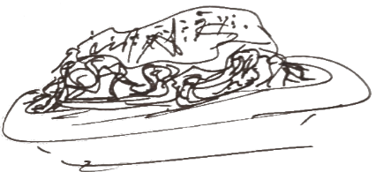
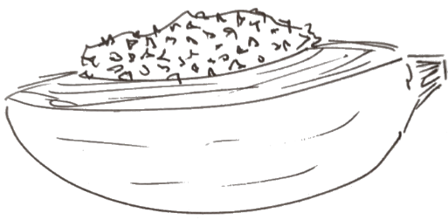
Add salt & pepper until it tastes good. You can also add stuff like oregano, basil, or whatever other herbs seem fun. Let it simmer until the beef is cooked & everything else also looks cooked. Done!

